Teaching African Canadian History in the Home

The Archives of Ontario has numerous records relating to Black History in the province. For an introduction to these, explore the online exhibits.
http://www.archives.gov.on.ca/en/explore/black_history.aspx



Our Stories - Remembering Niagara's Proud Black History Creator(s): Norval Johnson Heritage Centre
http://www.virtualmuseum.ca/sgc-cms/histoires_de_chez_nous-community_memories/pm_v2.php?id=exhibit_home&fl=0&lg=English&ex=00000659

The Virtual Museum of Canada presents: African Canadian Workers from 1900 to the Second World War
http://www.virtualmuseum.ca/edu/ViewLoitCollection.do;jsessionid=141C0B8DDEB74CF3C51C52DF86D93067?method=previewAbout&lang=EN&id=18627


This Black History Month resource will help students gain knowledge about the history and contributions of African civilizations and people of African descent in Canada while using media literacy skills as a vehicle to explore various aspects of Black history.
https://www.classroomconnection.ca/bhm.html

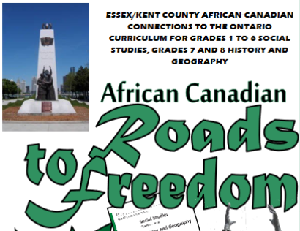

These two resources are intended to provide background information on African-Canadian heritage and culture. The information is connected directly to specific learning expectations in The Ontario Curriculum.
https://www.publicboard.ca/Programs/K-12/africancanadians/Pages/Roads-to-Freedom.aspx

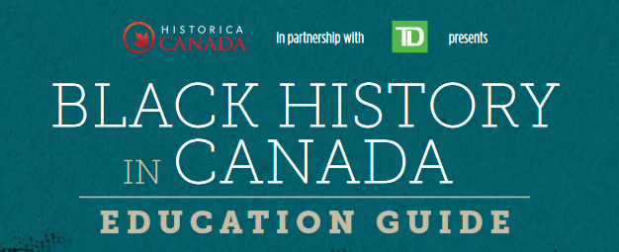

The Black History in Canada Education Guide explores events and personalities in Black Canadian history through engaging discussion and interactive activities. This innovative bilingual tool contains updated revisions from the original Guide, which was created in 2010.
http://education.historicacanada.ca/files/19/EN_BlackHistory_Digital.pdf



Windsor Mosaic presents ' African Canadian Community,' a site which recognizes
and pays tribute to the vital role of the African Canadian community in the Windsor Mosaic.
http://www.windsor-communities.com/african-introduction.php

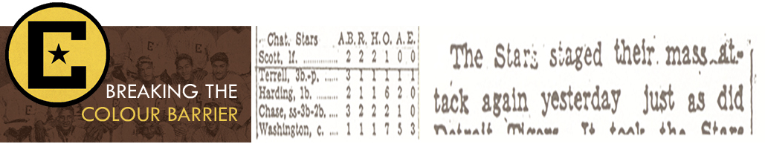

This website tells the story of the Chatham, Ontario baseball team who became the first Black team to win a provincial Ontario Baseball Amateur Association championship in 1934. Also, you will find (grades 1 – 12) lesson plans about the story of Boomer Harding and the Chatham Coloured All-Stars. These engaging, cross-curricular activities are aligned with the Ontario Curriculum.
http://cdigs.uwindsor.ca/BreakingColourBarrier/
http://cdigs.uwindsor.ca/BreakingColourBarrier/curriculum

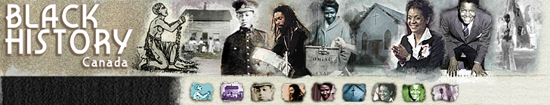

Explore profiles, resources, and a timeline to learn more about Black History in Canada.
http://www.blackhistorycanada.ca/

CBC Digital Archives has pulled together a selection of radio and TV clips that honour Black history -- some of which exemplify the racism Blacks have had to endure and overcome, both in Canada and around the world, while others highlight the remarkable accomplishments of extraordinary people.
http://www.cbc.ca/archives/topic/celebrating-black-history

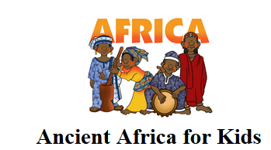

This site is an excellent resource about ancient African kingdoms, history, geography, music, folktales, and much more.
http://africa.mrdonn.org/index.html



Explore the Anti-Slavery Movement in Canada.
http://www.collectionscanada.gc.ca/anti-slavery/index-e.html



Explore the profiles of famous Black Canadians.
http://www.mysteriesofcanada.com/Canada/black_canadians.htm



An excellent collection of information and resources about the immigration of Blacks to Canada.
https://www.bac-lac.gc.ca/eng/discover/immigration/history-ethnic-cultural/Pages/blacks.aspx

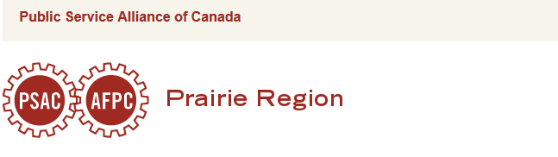
The PSAC BC Racially Visible Caucus and the Union of National Employees BC and Yukon have developed a series of posters, facts, and bookmarks to Celebrate Black History Month and commemorate our heritage.
http://prairies.psac.com/celebrate-black-history-month-these-educational-posters


The story of Viola Desmond, an entrepreneur who challenged segregation in Nova Scotia in the 1940s.
https://www.historicacanada.ca/content/heritage-minutes/viola-desmond


Explore the Educational Portal for information and links related to the Black experience.
http://www.yorku.ca/nhp/edulinks.htm

Learn more about slavery in New France.
https://www.historymuseum.ca/virtual-museum-of-new-france/population/slavery/

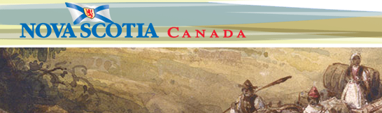
Learn more about the history and contributions of African Nova Scotians.
https://novascotia.ca/archives/Africanns/archives.asp?ID=1


Africville was a small settlement that formerly enslaved Blacks established in Nova Scotia after the War of 1812. In 1967, the City of Halifax demolished the settlement, displacing more than 400 residents. Learn more about this once thriving community and the racism that resulted in it’s destruction.
https://www.cbc.ca/archives/topic/africville-expropriating-black-nova-scotians


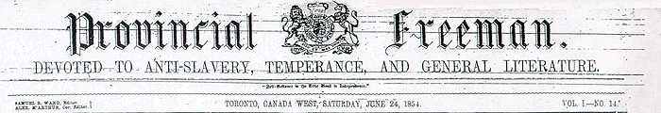

The Provincial Freeman was published from March 24, 1853 to September 20, 1857, first in Windsor, then in Toronto and Chatham. Published weekly, it advocated equality, integration and self-education for Black people in Canada and the United States. It was co-edited by Mary Ann Shadd Cary, the first Black woman publisher in North America and the first woman publisher in Canada, and the Reverend Samuel Ringgold Ward (1817-1867). Explore the collection at:
http://ink.ourdigitalworld.org/pf


This site explores the tradition of military service by Black Canadians.
https://www.veterans.gc.ca/eng/remembrance/those-who-served/black-canadians-in-uniform/history

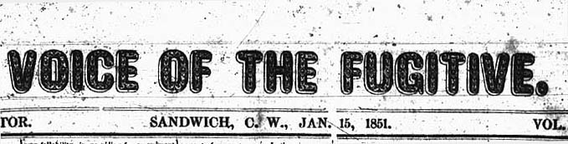

Voice of The Fugitive was one of the first Black newspapers in Upper Canada that was aimed at fugitive and escaped slaves from the United States. It began publication on January 1st, 1851 in Sandwich, Canada West. Explore the collection at:
http://ink.ourdigitalworld.org/vf

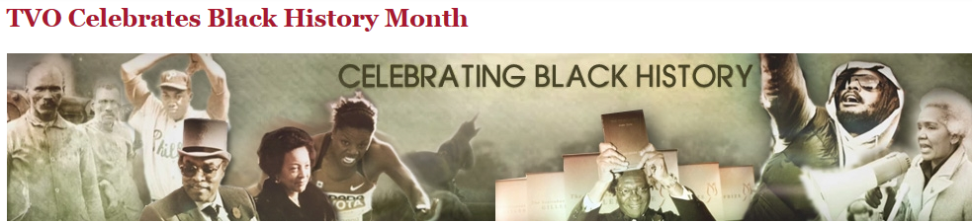

Explore a variety of resources celebrating Black History Month in Canada.
https://www.tvo.org/search/black%20history

Information and resources that honour the legacy of Black Canadians, past and present.
https://www.canada.ca/en/canadian-heritage/campaigns/black-history-month.html



The 1,280 images in this collection have been selected from a wide range of sources, most of them dating from the period of slavery. This collection is envisioned as a tool and a resource that can be used by teachers, researchers, students, and the general public - in brief, anyone interested in the experiences of Africans who were enslaved and transported to the Americas and the lives of their descendants in the slave societies of the New World.
http://www.slaveryimages.org/



With this interactive slideshow, students follow the path of an enslaved person in 1860 as they courageously travel the Underground Railroad to freedom. There are many activities and resources on this site.
http://teacher.scholastic.com/activities/bhistory/underground_railroad/


ETFO’s latest project, the 365 Black Canadian Curriculum, is part of a compilation of equity resources for elementary educators. These resources, which support Black Canadian history in Ontario schools on a daily basis, include: a calendar; primary, junior and intermediate lesson plans; a workshop for staff; and a poster. With this resource, educators will have historically factual information to support the learning of issues concerning race and discrimination, while ensuring safe learning environments for students to discuss these topics in a respectful and reflective manner, while also exploring the realities of Black Canadians. ​

http://www.etfo.ca/SupportingMembers/Resources/Pages/365.aspx



The Black History in Canada issue of Kayak and the accompanying educational materials can be found here.
https://mailchi.mp/canadashistory/black-history-in-canada-kayak-issue-education-package?e=f7a57a0608



The documents and images in this exhibit come from the collections of the Archives of Ontario and from other heritage organizations as noted.
http://www.archives.gov.on.ca/en/explore/online/slavery/index.aspx

