Welcome to Sandwich Secondary School

HOME OF THE SABRES!!

**Items needed for registration:**

* *Transfer package* from the current school, which includes a transcript, a credit counselling summary and an attendance record,
* *Online registration completed*, to access, go to **https://register.publicboard.ca/**
* *Status in Canada verification*: Birth certificate, Passport, Permanent Resident Card, Study Permit or other documentation,
* *Home Residency documentation*, 2 forms required from the items below:

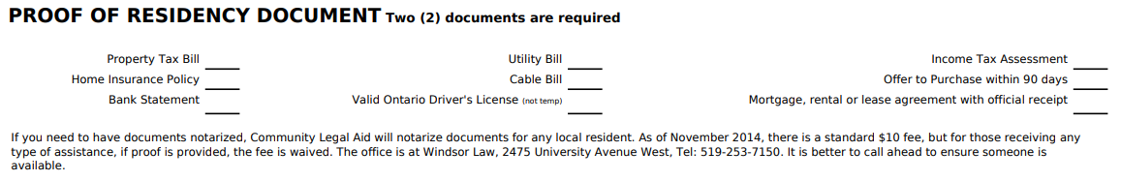

* Once the transfer package has been obtained and all documentation has been assembled, please contact the guidance office at Sandwich Secondary School at 519-734-1237, Ext 31206, so that a registration appointment can be scheduled.

**NOTE:** If your district school is not Sandwich Secondary School, please complete the online registration for your child’s home school and make note of the 5-digit registration ID at submission so that you can give it to the guidance secretary when you call for the appointment. The registration information can be transferred to Sandwich Secondary but no bussing will be available for out of district students.