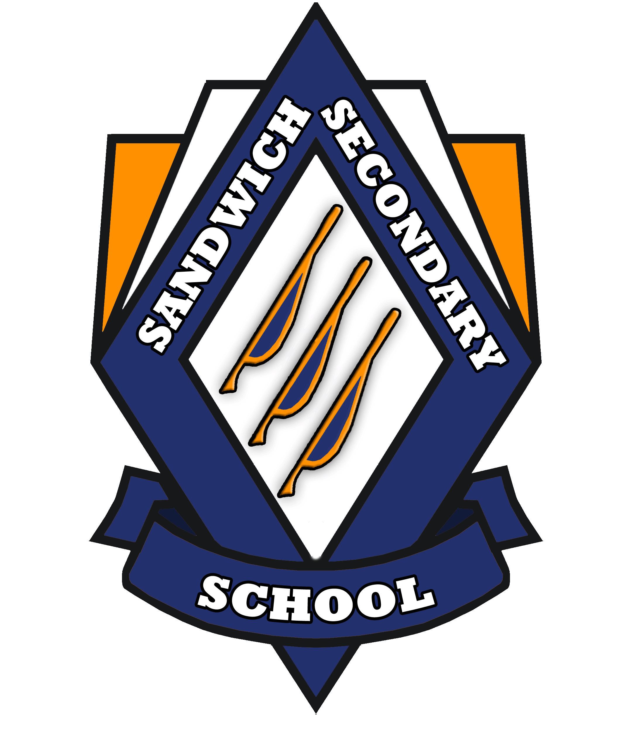
RELEASE OF INFORMATION
I hereby authorize:
Sandwich Secondary School
7050 Malden Rd., LaSalle, ON N9J 2T5

to release school records concerning myself on: ________________
Today’s Date

Full Name: ________________________________ Maiden Name: ___________________

Date of Birth: ___________________ Male: Female
YYYY/MM/DD

Address: _____________________________________________________________________
Street # Street Name City/Prov. Postal Code

Telephone#: (____)____________ Cell#: (___)_______________

______________________________________
Signature of Authorization

Last School Attended: __________________________ Last Year Attended: ______________

>>>>>>>>>>>>>>>>>>>>>>>>>>>>>>>>>>>>>>>>>>>>>>>>>>>>>>>>>>>>>>>>>>>

Official Transcript $10.75 each Proof of Identification Birth Certificate

Manual Transcript/Letter $16.00 each Drivers Lic.

Replacement Diploma $26.25 each Other

Additional Information:
____________________________________________________________________________
____________________________________________________________________________
____________________________________________________________________________
____________________________________________________________________________
____________________________________________________________________________
____________________________________________________________________________
____________________________________________________________________________
____________________________________________________________________________

