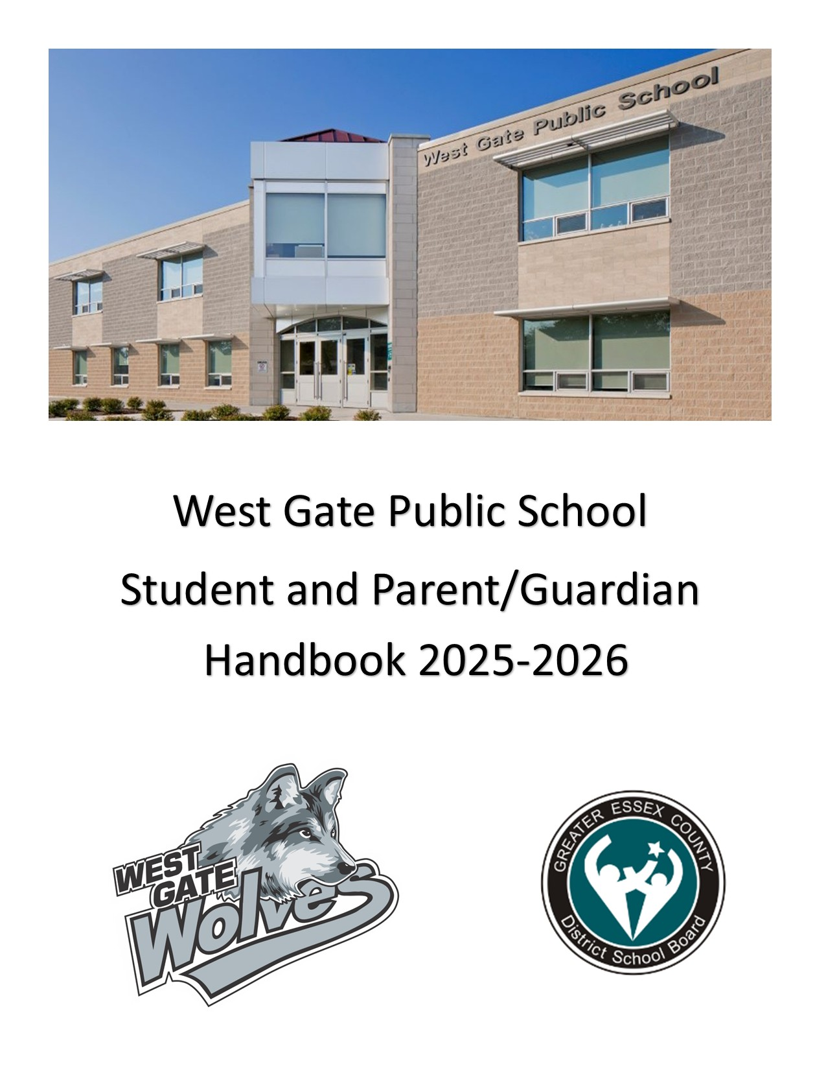

**TABLE OF CONTENTS**

1. **ABOUT OUR SCHOOL**
2. **ADDRESSING INAPPROPRIATE BEHAVIOUR**
3. **ASSEMBLIES**
4. **ATTENDANCE**
5. **BREAKFAST CLUB**
6. **BULLYING**
7. **CODE OF CONDUCT**
8. **COMBINED GRADES**
9. **CONCUSSION REPORTING**
10. **DAILY SCHEDULE**
11. **EARLY AND ONGOING INTERVENTION STRATEGIES**
12. **EARLY DISMISSAL**
13. **EDSBY**
14. **HEALTH**
15. **INCLEMENT WEATHER**
16. **LUNCH**
17. **MEDICATION**
18. **PARENTS/VISITORS**
19. **PERSONAL COMMUNICATION AND COMPUTING DEVICES**
20. **PERSONAL POSSESSIONS**
21. **PHYSICAL EDUCATION PROGRAM**
22. **PREVALENT MEDICAL CONDITIONS**
23. **PRIVACY OF INFORMATION**
24. **PROGRESSIVE DISCIPLINE POLICY FOR DOUGALL SCHOOL**
25. **SAFE ARRIVAL**
26. **SCHOOL COUNCILS**
27. **SMOKE FREE ENVIRONMENT**
28. **SUPERVISION OF STUDENTS**
29. **SUSPENSION INFRACTIONS**
30. **TELEPHONE NUMBERS**
31. **TRANSPORTATION AND STUDENT DROP-OFF**

West gate Public School Handbook

Together we are better!

### ABOUT OUR SCHOOL

In 2003, J.E. Benson Public School was declared Prohibitive to Repair by the Ministry of Education and approximately $8.5 million was provided to replace the Wyandotte St. school which had been built in 1915. Plans were made and a design created for a new J.E. Benson Public School in 2007, but the Ministry ordered a hold on the project due to dramatically declining enrolment in the area. A Program and Accommodation Review Committee (PARC) study was ordered by the Board of Trustees in 2010 for the Benson and Dr. H.D. Taylor school communities. A recommendation was approved in April, 2011 to combine the schools in a new building, West Gate, to be built on the Dr. H.D. Taylor property on Campbell Avenue.

Students entered the new school for the first time at the beginning of the 2014-15 school year with a celebration of opening in January of 2015. The celebration was held to show appreciation to all those who had a hand in the creation and realization of this West Windsor jewel.  A packed house of community members, staff, students and parents gathered in the gymnasium to listen as West Gate students of all ages described what the school meant to them and what it meant to be West Gate Wolves, ultimately welcoming the community to their new den.

West Gate Public School

1275 Campbell Avenue

Windsor, ON

N9B 3M7

Tel: 519-252-7729

Fax: 519-252-7868

Principal: Mr. Josh Raycroft

Vice-Principal: Mr. Chris Knight

Senior Secretary: Ms. Liz Bolton

Clerk: Ms. Nicole Cragg

Trustees: Ms. Kim McKinley and Ms. Linda Qin

### ADDRESSING INAPPROPRIATE BEHAVIOUR

If a student has displayed inappropriate behaviour the principal or designate may utilize a range of interventions, supports, and consequences that are (1) developmentally appropriate, and (2) include opportunities for students to focus on improving their behaviour.

Inappropriate behaviour includes any behaviour that disrupts the positive school climate and/or has a negative impact on the school community.

Inappropriate behaviour may also include, but is not limited to, one of the following infractions for which a suspension may be imposed:

1. Any act considered by the principal to be injurious to the moral tone of the school;

2. Any act considered by the principal to be injurious to the physical or mental well- being of any member of the school community; and

3. Any act considered by the principal to be contrary to the Board or school Code of Conduct.

If a student has engaged in inappropriate behaviour, the principal or designate may choose to use a progressive discipline strategy to address the infraction.

Interventions may include, but are not limited to:

- Meeting with the student’s parent(s)/guardian(s), student, and principal;

- Referral to a community agency;

- Detentions;

- Behaviour Plans;

- Withdrawal of privileges;

- Supervised withdrawal from class;

- Restitution for damages;

- Consultation;

- Suspension (subject to mitigating circumstances); or

- Expulsion (subject to mitigating circumstances).

### ASSEMBLIES

Our student of the month assemblies are typically on the last Thursday of the month. At assemblies we acknowledge students demonstrating character (e.g. kindness, respect) and sometimes have special presentations by students.

These assemblies are foundations for school spirit and for the reinforcement of individual positive self-image. Families will be contacted by teachers for students who are presenting and/or receiving and award.

### ATTENDANCE

Regular attendance is required by law and is essential to good pupil attitude. You can help to promote the academic success of your child by ensuring that they arrive at school on time and are consistent in their attendance. You may drop your child off at school after 8:20am. Students enter the building to begin the school day at 8:35am and are dismissed at the end of the day at 2:55pm. Dismissal is located at the fenced area by our bus bay and parking lot. We ask that only students and staff are on the blacktop area. Families here for pickup should remain behind the fence.

### BREAKFAST CLUB

The Breakfast Club will continue to operate this year thanks to the efforts of community volunteers and donations from several community sources.

A message to the community will be sent early in the year with the start date and days of operation.

### BULLYING

Bullying is typically a form of repeated, persistent, and aggressive behaviour directed at an individual or individuals that is intended to cause (or should be known to cause) fear and distress and/or harm to another person’s body, feelings, self-esteem, or reputation. Bullying occurs in a context where there is a real or perceived power imbalance.

**Verbal bullying behaviours may include:**

* Name calling, put downs, insults, taunts, sarcasm
* Racial and/or religious slurs
* Hurtful comments about sexual gender and preference
* Spreading rumours
* Telling students not to play or interact with another
* Unwelcomed comments that degrade or make another feel uncomfortable
* Intimidating telephone calls, emails, text messages
* Threats of violence

**Non-Verbal bullying behaviours may include:**

* Graffiti
* Hateful or hurtful written comments
* Written comments telling others to exclude, ignore or reject another person
* Revealing personal information that could lead to public humiliation
* Internet bullying behaviour

**Physical bullying behaviours may include:**

* Hitting, pushing, kicking, shoving, poking, chasing, spitting
* Physical intimidation or assault - with or without a weapon
* Defacing or destroying property
* Stealing
* Unwanted touching

The staff works diligently to ensure West Gate Public School is free from bullying. We can’t do it alone. Please reinforce the following strategies with your child:

* Seek help from an adult or a peer
* Make assertive statements to the bully addressing your feelings
* Look the bully in the eye and say, “Stop”
* Walk away from the bully

If students know that someone is being bullied, they should report the situation to the closest teacher or an adult in the building. Incidents of bullying regardless of place of origin may be dealt with at the school level if it affects the moral tone of the school and/or welfare of students.

Need Help NOW? 24/7 Support

Kids Help Phone 1-800-668-6868 Text: CONNECT to 686868

### CODE OF CONDUCT

1. Respect for Others – Students are expected to demonstrate respect for others. Misbehaviour such as disobedience, rudeness, swearing, threats or harassment will not be tolerated.

2. Respect for Personal and School Property – Students are expected to exercise proper care of school materials, equipment, and furniture. Students should know that vandalism is costly and that violators will have to pay for damages incurred.

3. No Physical Abuse – Students are expected to treat each other’s bodies with respect. The following is unacceptable behaviour: pushing, kicking, fighting, spitting, rough play, throwing sand or other objects etc. Also, in winter, our general rule is that snow stays on the ground.

4. Punctuality, dependability, and dedication to tasks are three qualities we wish our students to appreciate and attain. Therefore, we expect our students to arrive at school and between classes on time. Furthermore, students are expected to be ready to work and learn when classes begin and to hand in their assignments on time.

### COMBINED GRADES

Many parents are often worried and hesitant when they hear that their children have been placed in a room with a combined grade. Combined grades are usually a measure to accommodate a number of students in a school’s enrollment. Sometimes there are too many students for one class but not enough to form two complete classes at that grade level. The amount of time a teacher must give individual attention to his/her students is determined by the number of students in the class, not by the composition of the class. Pupils receive as much instructional time as they would in a straight grade where grouping is common and expected.

### CONCUSSION REPORTING

In the best interest of your child, parents/guardians are requested to communicate with the school principal, prior to the student’s attendance at school, whenever there is a suspected or diagnosed concussion that occurs off school site (e.g., at home or at a sporting activity).

To appropriately manage a suspected concussion, it is necessary for the school to initiate the Concussion Protocol, more specifically the “Return to Learn” and “Return to Physical Activity” plans. These are designed to minimize the risk of further injury and prevent the worsening of a concussion. It is with this communication of information that the school, in consultation with parents/guardians, can immediately begin managing the student’s concussion and follow a medically supervised, individualized, and gradual Return to School (RTS) and Return to Physical Activity (RTPA) Plan.

For further information please refer to the Ontario Physical and Health Education’s website (OPHEA) and Parachute Canada’s website: http://safety.ophea.net/concussions

### DAILY SCHEDULE

8:35 am Entry

8:35 am to 10:15 am First Learning Block

10:15 am to 10:55 am Nutrition Break

10:55 am to 12:35 pm Second Learning Block

12:35 pm to 1:15 pm Nutrition Break

1:15 pm to 2:55 pm Third Learning Block

2:55 pm Dismissal

### EARLY AND ONGOING INTERVENTION STRATEGIES

The teacher, in collaboration with administration, as appropriate, may utilize early and/or ongoing intervention strategies to address unsafe or inappropriate behaviours. These may include but are not limited to:

- Contact with student’s parent(s)/guardian(s);

- Verbal reminders;

- Review of expectations;

- Written work assignments addressing the behaviour with a learning component;

- Assigning the student to volunteer services in the school community;

- Conflict mediation and resolution;

- Referral to counselling, as applicable;

- Referral to community agencies;

- Positive Behaviour Management Plans; and/or

- Consultation.

### EARLY DISMISSAL

If you wish to have your child released from school at a time other than at regular dismissal, please send a note or call the school. Due to supervision difficulties, we cannot call students down to the office before a parent/guardian arrives. Parents/guardians must come into the school. At that time, the secretary will call the student down to the office.

### EDSBY

The Greater Essex County District School Board (GECDSB) offers Edsby across all schools to families and students from kindergarten to Grade 12. Edsby is a cloud-based tool that offers real-time access to students’ attendance, schedule, activities, and classroom work. Edsby also provides resources to connect families with teachers and the latest school news and information. Please call the school if you require assistance setting up your Edsby account.

### HEALTH

We require health information, work phone numbers, and emergency phone numbers so that your child can be cared for should he or she become ill or has an accident at school. We ask that you fill out an information update sheet each September. Please inform us of any changes to ensure that the information we have is accurate. Throughout the year, cases of illness occur, and children need to remain home to recuperate. In cases of head lice, parents will be informed that a child in their child’s class is experiencing a particular situation. Often children experiencing a cold, or the flu wish to come back to school to maintain good attendance records. This is not fair to other students in the class as colds or the flu spread rapidly in the school environment.

We request that you do not send a note requesting permission to remain indoors. If you feel that your child is not well enough to play outside, please keep him or her home for an extra day until he or she can participate in all school activities. There are specific situations relating to an injury in which we will accommodate your child’s needs.

PLEASE NOTE: If your child has a medical or health-related concern, be sure that the office and teacher are made aware of it.

### INCLEMENT WEATHER

In the event of severe weather conditions, the Greater Essex County District School Board will inform local radio stations as to whether or not buses are running or schools will be open. Visit our Board website and choose student links to visit the BusKids website for further information. http://www.publicboard.ca/

When the weather is extremely cold or rainy, children will be admitted to the school at 8:20 am and will stay inside during recess and lunch hour. Students remain inside when the wind chill temperature reaches minus 20 degrees. In case of severe weather, parents should decide whether to send children to school. If severe weather occurs during school hours, children will be kept at school until regular dismissal. It would be wise to have emergency preparations made so that your child does have a place to go if you are not home during a severe weather emergency.

### LUNCH

We believe the best situation is one where children stay at school and are supervised by Staff/ Part Time School Aides. We cannot guarantee your child’s safety if they leave school grounds. Only grade 7/8 students are permitted to walk home for lunch during second nutrition break. A lunch form must be signed by a parent/guardian and can be obtained at the office. Leaving during lunch is a privilege that can be removed if students are not able to follow the lunchtime routines;

a.) be on time

b.) home and back to school for 1:15p

c.) not attending local stores or restaurants

We provide supervision for the students who bring their lunch to school.

Please label your child’s lunch bag to avoid a mix-up should a lunch or lunch bag be misplaced. If you are bringing your child’s lunch after the start of the normal school day, please label it clearly and drop it off at the office.

To ensure their safety during the lunch hour, students who bring lunch to school will not be allowed to leave the school grounds. Parents allowing their son/daughter to leave the grounds over the lunch hour must sign the “Lunch Permission Form” that is handed out to Grades 7 and 8 students at the beginning of the school year.

### MEDICATION

Board policy requires that no medication be given to children by school staff unless an Administration of Medication Form is signed by the child’s physician. This form is available from the school office.

### PARENTS/VISITORS

The Greater Essex County Board of Education policy states that all parents/guardians check in at the office before visiting the school. This is to ensure the safety and protection of our children.

### PERSONAL COMMUNICATION AND COMPUTING DEVICES

The use of personal communication and/or computing devices such as cellular phones, laptops, tablets or other electronic communication devices, are not permitted in school buildings during instructional time except:

1. When an emergency requires a 911 call.

2. When permitted and supervised by a staff member for educational purposes only.

Students who choose to bring personal communication and/or computing devices to school do so with the understanding that:

1. These devices are the responsibility of the owner and the GECDSB and/or school are not liable for damage, loss, or theft of the device or data that is stored on the device.

2. These devices are to be off during instructional time unless it is approved by a staff member.

3. These devices may not be used at any time where individual privacy must be protected such as recess, washrooms, or change rooms.

Students will be subject to school discipline, per the school and board policy relative to the Code of Conduct, when:

1. Such a device is used in such a way that it disrespects another’s privacy;

2. Such a device is used to bully or harass;

3. Such a device is used without staff permission.

Students are not permitted to take photos, audio, and/or video in school buildings or during off site school sponsored events before, during or after school unless they have permission from school staff and the people being photographed/recorded in advance.

### PERSONAL POSSESSIONS

West Gate Public School cannot be held responsible for lost or damaged personal possessions. Valuable items such as phones, jewellery, collector cards, toys and expensive clothing should be left at home. Roller blades, skateboards, wheelies, scooters, hardballs, hockey sticks, Frisbees, etc. are not to be used on school property. The GECDSB does not carry insurance to cover damage or loss to personal possessions.

### PHYSICAL EDUCATION PROGRAM

Your child will spend time in the gym each week. To fully benefit from the program, a pair of running (or soft-soled shoes) and loose-fitting, comfortable clothing (a pair of shorts and a T-shirt for example) are recommended. Please label these items. The children are not allowed to participate in bare feet/boots/sandals for health and safety reasons. They cannot take Phys. Ed. in stocking feet.

### PREVALENT MEDICAL CONDITIONS

At West Gate, we strive to provide safe and consistent measures to address the needs of our students’ health. This includes but is not limited to the administration of medication and prevalent medical conditions (anaphylaxis, asthma, diabetes and/or epilepsy). To support families in feeling confident that their child is safe at school and during school related activities, we will be working with parents to create a Plan of Care, for students that have been diagnosed by a medical practitioner as having a prevalent medical condition (anaphylaxis, asthma, diabetes and/or epilepsy). Students with existing plans will have the chance to update/alter these at the beginning of the school year when a copy for revision will be sent home and must be returned.

### PRIVACY OF INFORMATION

It is the policy of the Greater Essex County District School Board to collect, use, retain and disclose personal information in the course of meeting its statutory duties and responsibilities. The Greater Essex County District School Board is committed to the protection of privacy and complies with all applicable provisions in the Education Act, the Municipal Freedom of Information and Protection of Privacy Act (MFIPPA), the Personal Health Information Protection Act (PHIPA), and any other applicable legislation.

### PROGRESSIVE DISCIPLINE POLICY

West Gate adopts the Progressive Discipline Policy of the Greater Essex County District School Board. The Progressive Discipline Policy is to support a safe learning and teaching environment.

Progressive discipline is an approach that makes use of a continuum of interventions, supports, and consequences, building upon strategies that promote positive behaviours. When inappropriate behaviour occurs, disciplinary measures should be applied within a framework that is both corrective and supportive.

Students, teachers, school staff, principals and parents/guardians are encouraged to disclose necessary information regarding inappropriate behaviour and/or acts of aggression to facilitate timely responses that meet the needs of both the victim and perpetrator. Failure to disclose inappropriate behaviour to facilitate a timely and appropriate student-centred response can create a perception that inappropriate behaviour is condoned, or accepted practice in schools.

### SAFE ARRIVAL

To ensure the safety of our students, the school needs to know about absences and late arrivals. When a student is absent or will be late, the parent/guardian has the responsibility of contacting the school using Edsby or by telephone (519-252-7729) to advise the secretary. If a call is not received, the school will contact the parent/guardian at home or at work to account for the student. If the secretary cannot reach the parent/guardian, she will attempt to contact the emergency contact.

### SCHOOL COUNCILS

The “Education Quality Improvement Act, 1997” required that School Councils be established in each school in Ontario. The School Council is a vehicle for parents to have a voice in the education of their children. It is also pivotal in keeping the parents and other members of the school community informed of changes as they are implemented at both the provincial and local levels. Members of the School Council consist of parents, educators, non-teaching staff and appointed community members. The West Gate School Council will continue to work hard on your behalf to provide input on topics pertaining to the school’s educational program. The School Council meets regularly and all parents/ guardians are invited to join!

### SPECTATOR CODE OF BEHAVIOUR

All spectators should understand the following code:

1. Cheer in a positive manner.

2. Respect officials’ decisions.

3. Do not interfere with the competition.

4. Be courteous and respectful.

A students’ academic performance comes before athletic endeavours. Success in the classroom equals success in sport!

**All students must be accompanied by an adult to stay and watch home sporting events. **

### SMOKE FREE ENVIRONMENT

West Gate Public School is a Smoke Free Environment. The Board recognizes that a safe and healthy environment is one that is free from the harmful effects of using and/or smoking tobacco products, cannabis (other than medical cannabis by authorized medical cannabis users), and/or related tobacco, cannabis, or vapour product accessories, including by way of electronic cigarettes, and one that is free from the harmful effects of second-hand smoke. Student use of tobacco products, cannabis products or vapour products may result in student discipline, including suspension and/or a recommendation for expulsion, and/or a report to the Tobacco Enforcement Officer and/or the local police force as per the Board/Police Protocol. The Board’s regulation complies with the Smoke-Free Ontario Act, 2017, S.O. 2017, c. 26, Sched. 3.

### SUPERVISION OF STUDENTS

Student supervision at the school begins at 8:20 am in the school yard. It is important for parents to note that the school yard is not supervised before 8:20 am or after 2:55 pm. We ask for your cooperation to ensure the safety of your children.

### SUSPENSION INFRACTIONS

When a principal’s investigation of an incident determines that a student has committed one or more infractions outlined below on school property, during a school-related activity or event, and/or in circumstances where the infraction has an impact on the school climate, a principal will consider whether that student should be suspended, taking into account any mitigating and other factors that might be applicable in the circumstances.

The principal will also contact the police consistent with the Police-School Board Protocol if the infraction the student is suspected of committing requires such contact.

The infractions for which a suspension may be imposed by the principal include:

1. Uttering a threat to inflict serious bodily harm on another person;

2. Possessing alcohol, illegal and/ or restricted drugs;

3. Being under the influence of alcohol;

4. Swearing at a teacher or at another person in a position of authority;

5. Committing an act of vandalism that causes extensive damage to school property at the student’s school or to property located on the premises of the student’s school;

6. Bullying;

7. Any act considered by the principal to be injurious to the moral tone of the school;

8. Any act considered by the principal to be injurious to the physical or mental well-being of any member of the school community; or

9. Any act considered by the principal to be contrary to the Board or school Code of Conduct.

### TELEPHONE NUMBERS

It is essential for the school to have your home phone number and where parents/guardians can be reached during the day so that we may contact families in case of an emergency. Please notify us of any change in telephone numbers or emergency contacts.

### TRANSPORTATION AND STUDENT DROP-OFF

All students are to be dropped off at the fence nearest the parking lot.

A fence has been installed to close off the school yard at the North End of the yard (closest to the adjacent park).  There will be no access to the school property from this end.

If you are driving your child(ren) to school, please note to park in a designated parking spot or on the road where permitted.  You may also use the Kiss and Ride available in the morning.  We encourage all families to walk to school where possible an/or carpool.  Please drive extremely slowly and be cautious of families.

Students riding bikes/scooters are to walk on school property.  We are limited in the number of bike racks at school.  Students are responsible for locking their equipment.  The school is not responsible for lost/stolen or damaged equipment.  This includes any personal items that are brought to school.